# Software Testing Life Cycle (STLC)

The Software Testing Life Cycle (STLC) is a systematic approach to testing a software application to ensure that it meets the requirements and is free of defects. It is a process that follows a series of steps or phases, and each phase has specific objectives and deliverables. The STLC is used to ensure that the software is of high quality, reliable, and meets the needs of the end-users.

The main goal of the STLC is to identify and document any defects or issues in the software application as early as possible in the development process. This allows for issues to be addressed and resolved before the software is released to the public.

The stages of the STLC include Test Planning, Test Analysis, Test Design, Test Environment Setup, Test Execution, Test Closure, and Defect Retesting. Each of these stages includes specific activities and deliverables that help to ensure that the software is thoroughly tested and meets the requirements of the end users.

Overall, the STLC is an important process that helps to ensure the quality of software applications and provides a systematic approach to testing. It allows organizations to release high-quality software that meets the needs of their customers, ultimately leading to customer satisfaction and business success.

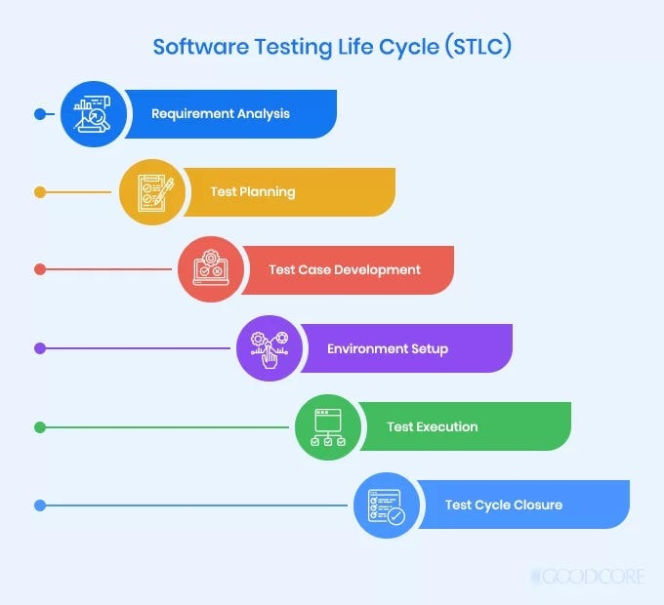

## **The Six Phases of STLC Phases**

### **1 Requirement Analysis**

It is the first phase of STLC which deals with the QA team analyzing and understanding the requirement document to start the testing process with accurate information.In the Requirement analysis phase, the entry criteria are requirement documents, acceptance criteria, and understanding of the product architecture. The exit criteria for this phase are approved Requirements Traceability Matrix (RTM) and automation feasibility reports that evaluate if the tests can be automated. All of this ensures that the testing process starts with the right information and focuses on the important areas of the software.

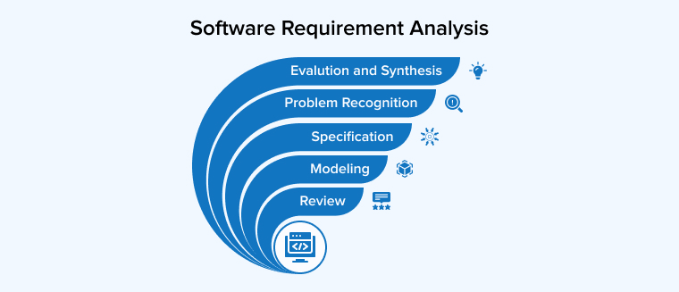

### **2 Test Planning**

After determining the user requirements, the next phase of STLC is to plan the tests. It is a critical step of STLC where all the test plans are defined, and a detailed strategy is laid out for the project. It includes developing test steps, assigning roles and responsibilities, and choosing the right testing approach and automation tools, if any. The QA team also calculates the estimated cost and resources to begin the testing.The entry criteria for the test planning phase are approved Requirements Traceability Matrix (RTM) and automation feasibility reports. The exit criteria are approved test plans, automation scripts, and defining the cost analysis of the complete project.

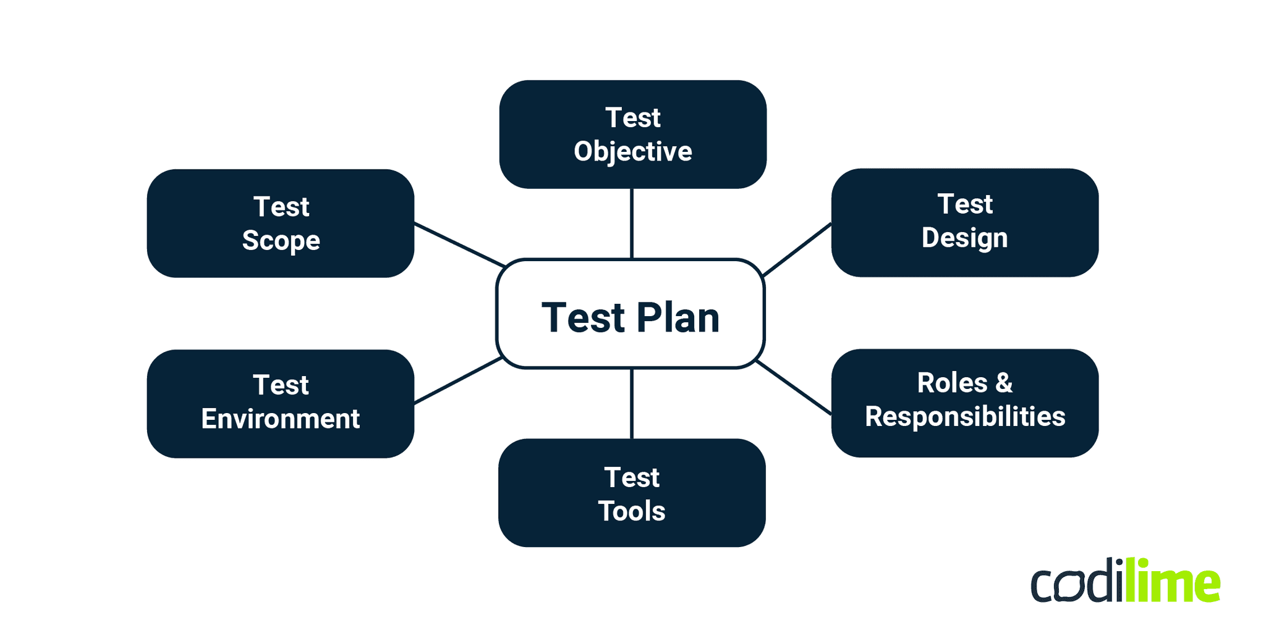

### **3 Test Case Development/Design**

After finishing the planning stage, this phase is designing and developing the test cases. In this step, the testing team creates the test steps with proper input, test execution conditions, and expected output for execution.For the test case design and development phase, the entry criteria are approved test plans, automation scripts, and defining the cost analysis of the complete project. The exit criteria are the approved test cases and automation scripts with the proper information for each test step.



### **4 Test Environment Setup**

This phase includes setting up a test environment to run your test cases and check the application for its efficiency. It decides the conditions to test your application and involves configuring and deploying the test environment. Often, this step also includes setting up test servers. You can either perform the test environment setup in sequence or execute it after the requirement analysis phase, as it is independent of all the previous phases.The entry criteria of this phase are requirement documents, system architecture details, and application design. The exit criteria are a fully up-and-running test environment to execute the approved test cases.



### **5 Test Execution**

After all the setup and planning are over, the test execution phase comes. The QA team runs the test cases and scripts to check the quality of the application. They compare the expected results with the actual results to understand which areas have issues and need attention.The entry criteria of this step are the combined exit criteria of all the previous steps, including test plans/cases, test environment, user requirement document, and more. The exit criteria are all the executed test cases with results.

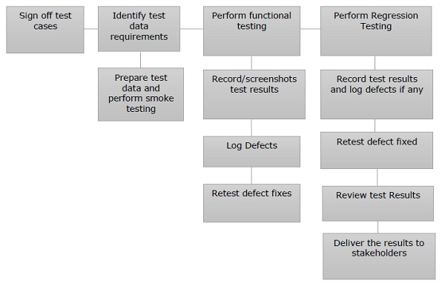

### **6 Test Closure**

The last phase of STLC is test closure which pertains to preparing a test result report. It summarizes the testing process and highlights the comparison between the actual and expected test results. The comparison includes the fulfilled project objectives, time taken to complete the testing, budget, test coverage, and identified issues.The entry criteria for the test closure phase are test results after executing all the test cases. The exit criteria are designed, delivered, and approved test results report.

